**SURVEY ON EXISTING TECHNOLOGIES/SYSTEMS:**

With the combination of technology and our homes, industries, schools and work places, we can build awesome future ahead.

We know how it feels after coming back home from a long tiring day from work. All we want and hope for is everything to be done on its own. We are now becoming dependent on technology for our basic tasks too and in this year of 2020 , it’s a luxury to own an automated home lifestyle. AI can make us stay away from frequent physical contact in times of COVID-19 pandemic.

So keeping in mind the need of security in our home and COVID-19, this report deals with Artificial Intelligence based Facial Recognition Lock Unlock Features at home and other places. Face recognition is used as a biometric security standard because of its ability and quickness to recognize faces.

**PROBLEM DESCRIPTION :**

Safety from possible Covid-19 Transmission with AI based Security Lock and Alert System

PROBLEM TITLE :

Biometric identification has the advantage of improving the user experience across all channels, greatly reducing the “friction” that usually causes traditional authentication systems in people. In other words, it is the view on the user and on how to simplify and improve his user experience that is guaranteeing the growth of the market to biometric systems and opening new opportunities for companies. 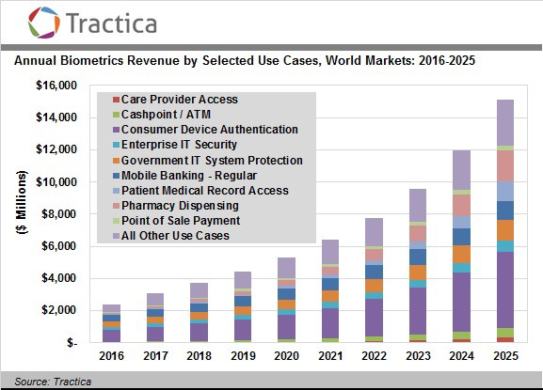

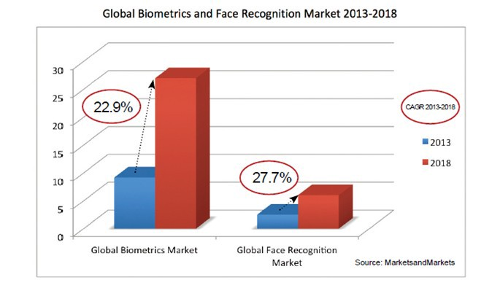

In the coming years, we will increasingly see the use of this type of authentication technologies that will give the opportunity to the players involved to integrate machine learning, data analysis and information from the sensors to make available to the users more and more reliable and simple technological solutions, offering a completely different customer experience from what we have known so far. An approach that for companies will result in many advantages in terms of cost, reliability, scalability and speed.

The majority of institutions and offices rely on Fingerprint Biometric for its users databases which needs to be upgraded as in 2020 we are in going through Pandemic so we must reduce the physical contact as much as possible.Thus,Facial recognition is a must now for authentication. Hence, lets enhance our development in this field.

**MY PROPOSED APPROACH :**

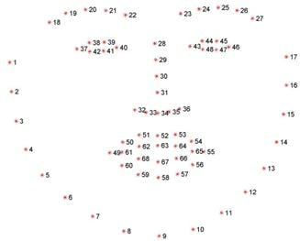My approach focuses on reducing the complexities of daily life to provide us a better ease of access to things using IOT and Application Programming Interface (APIs). As a requirement there will also be using various sms/email private API providing platforms according to our needs.

Anti-spoofing algorithm: Eye-blink based heuristic approach.

The EAR (Eye-Aspect-Ratio) produces a constant value when the eye is open and decreases rapidly when the eye gets closed (demonstrated in figure A). So this helps us immensely for accurate determination of the person’s eye blinks basing on the vertical and horizontal eye landmark points. The shape predictor will be implemented for the ROI (Region of Interest) in face.

**1.Virtual box software(Linux preferably)**

**2.** **Bolt IoT**

**3.** **OpenCV**

**4.Ip Camera(mobile can do with Ip camera app)**

**5.** **Twilio is a third-party SMS functionality provider.**

**6.** **Mailgun Configuration for Email.**

**7.Buzzer, Led, Breadboard, Internet Connectivity, jumper wires, USB cable ,DC power.**



**Stream video on local sever**

**BOLT IOT MODULE CONNECTED. FACIAL RECOGNITION INITITIATED**

**VIRTUAL PRIVATE SERVER**

**Block diagram of my proposed system :**

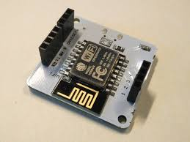

IP CAMERA

INTRUDER DETECTED :: WARNING SEND THROUGH MAIL, SMS ALERT, BUZZER AND ALARM LED TRIGGERED

LOCKED SECURELY

UNLOCKED

OWNER AND REGISTERED USER ACCESS GRANTED ::

ALERT NOTICATION > TRUSTED MEMBER ACCESS:::::::

**INTRUDER DETECTED:: ALERT**

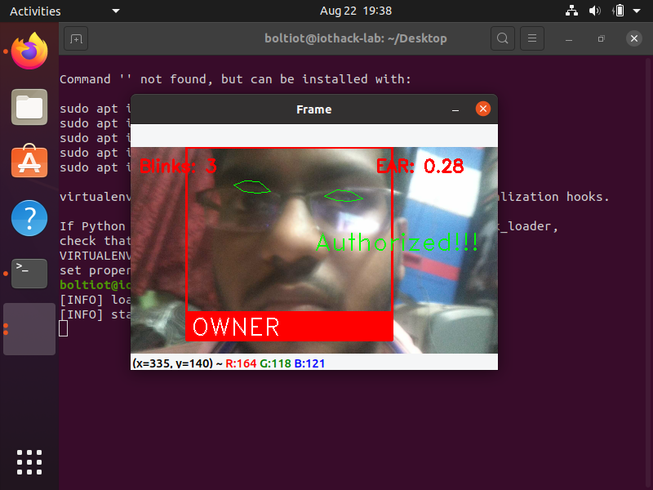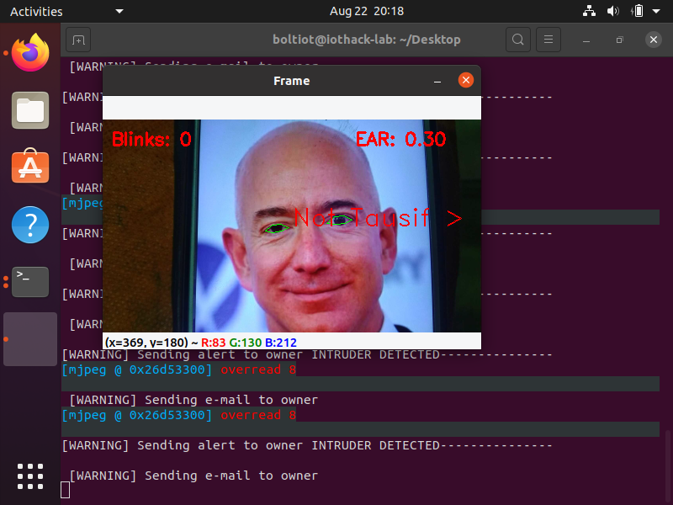 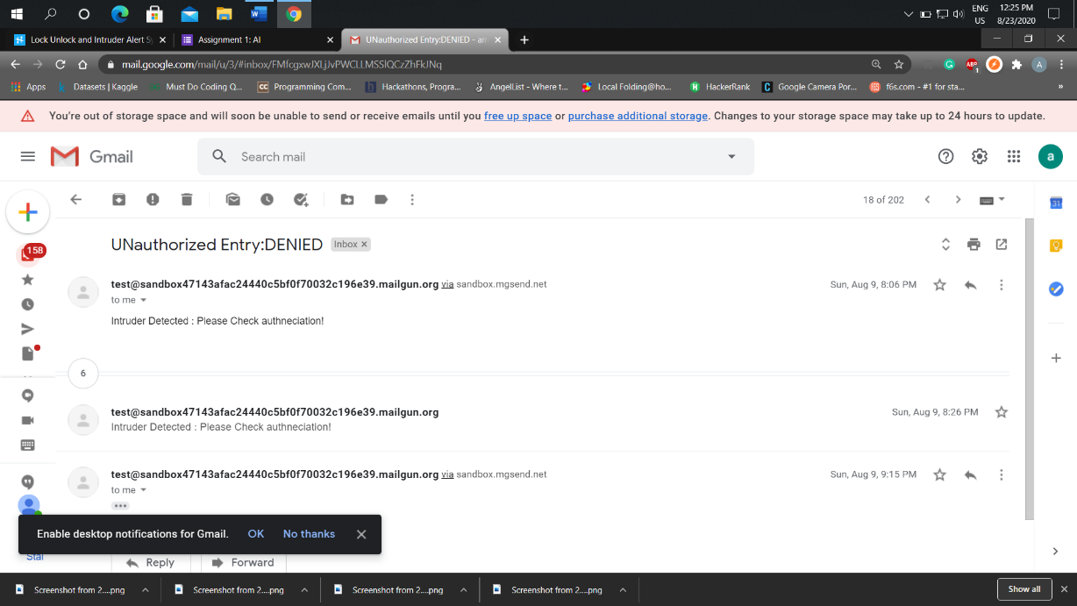 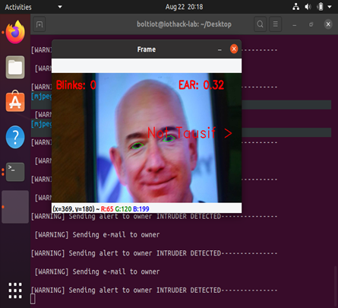

**CONCLUSIONS:**

DEMO SCREENSHOTS :

**Thus it is to infer that Artificial Intelligence with IOT are having great impact in our lives which helps in automation and security.In times of this pandemic more digital enhancement is promoted and hence its really very useful. Physical contact is minimum and better than Fingerprint.**

**In future this kind of idea could be made more advanced with advanced algorithms . But only downfall is that without internet this IOT is not useful. This is not flawless so we need correct it.**

**REFERENCES:**

1. [**https://medium.com/iquii/biometric-recognition-definition-challenge-and-opportunities-of-biometric-recognition-systems-d063c7b58209**](https://medium.com/iquii/biometric-recognition-definition-challenge-and-opportunities-of-biometric-recognition-systems-d063c7b58209)
2. [**https://www.researchgate.net/publication/336999850_Biometric_Technologies_in_Recognition_Systems_A_Survey**](https://www.researchgate.net/publication/336999850_Biometric_Technologies_in_Recognition_Systems_A_Survey)
3. [**https://trainings.boltiot.com/p/iotandml**](https://trainings.boltiot.com/p/iotandml)
4. [**https://www.simform.com/home-automation-using-internet-of-things/**](https://www.simform.com/home-automation-using-internet-of-things/)
5. [**https://www.pyimagesearch.com/2018/06/18/face-recognition-with-opencv-python-and-deep-learning/**](https://www.pyimagesearch.com/2018/06/18/face-recognition-with-opencv-python-and-deep-learning/)
6. [**https://realpython.com/face-detection-in-python-using-a-webcam/**](https://realpython.com/face-detection-in-python-using-a-webcam/)